Visit www.DeepL.com/Pro for more information.

ripartizione Didattica e servizi agli studenti

AREA post laurea

UFFICIO MASTER E DOTTORATI

Model 1

(reserved for regional grant winners)

DECLARATION OF AVAILABILITY TO ACCEPT THE REGIONAL GRANT FOR THE PHD COURSE IN - th cycle.

TO THE MAGNIFICENT RECTOR UNIVERSITY OF SALENTO
Viale Gallipoli, 49
73100 - LECCE
amministrazione.centrale@cert-unile.it

Subject: POR Puglia FESR ESF 2014-2020 - Axis X - Action 10.4 "Interventi volti a promuovere la ricerca e per l’istruzione universitaria" - funding of regional research grants "PhDs in Puglia XXXVI Cycle" - declaration of willingness and commitment to accept the grant.

SELF DECLARATION
(art. 47 del DPR 28 dicembre 2000, n. 445)

I, the undersigned ………………………………………………………………………………………………………… Born in ……………………………………………………………residing in …………………………
Street ………………………………………………………………………………………………………………

tax code ……………………………………………………………………………………………………………, email ………………………………………………………..
recipient of a regional scholarship for the PhD course in ________________________ of a PhD scholarship funded by POR Puglia ERDF ESF 2014-2020 - Axis X - Action 10.4 " Interventi volti a promuovere la ricerca e per l’istruzione universitaria " - funding regional research scholarships " Dottorati di ricerca in Puglia _______ Ciclo " under its civil and criminal liability, formally declares:

- that he / she does not benefit or that he / she will renounce other scholarships for any reason whatsoever conferred during the period of the regional scholarship and he / she undertakes not to benefit from other scholarships, except for those eligible under the regulations in force;

b) that he / she undertakes to send, for statistical purposes, to the address amministrazione.centrale@cert- unile.it the current declaration of the University ISEE (as requested by the Apulia Region) and that he / she
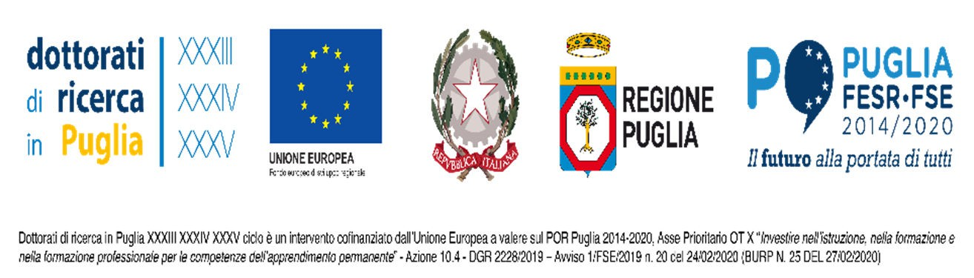

BREAKDOWN DIDACTICS AND STUDENT SERVICES
POSTGRADUATE AREA MASTER'S AND DOCTORATES OFFICE

undertakes to subsequently send all other information that will be requested by the Apulia Region on the basis of SIGECO indications (see Appendix 2 of POS D.4 of the Management and Control System of POR PUGLIA ERDF-FSE 2014-2020) and which are necessary for the award of the scholarship. If these requirements are not met, the regional grant cannot be awarded or disbursed;

c) he / she undertakes to guarantee the regular performance of the research activities foreseen for the PhD Course and assigned by the Board of Teachers and the achievement of the results indicated in the Notice, and to fully comply with the provisions of EU, state and regional regulations in force and on structural funds, expressly referred to in the above mentioned Notices;

- he / she is aware that the modification of the project objectives and expected results (if not previously authorised by the Region) may result in the revocation of the grant and the total or partial refund of the amounts already paid. Any variation, which should become necessary, must be duly justified and approved in advance by the Education and University Section of the Region of Puglia, which will, if necessary, approve it. Any deviation from what was presented at the time of eligibility of the application and approved by the evaluation team, will be subject to analysis with a view to a possible withdrawal of funding or financial correction;

e) he / she is aware that any negative judgement of the Board of Teachers and the consequent non- admission to the following year of the course may result in the total or patient revocation of the entire scholarship or part of its accruals;

Date

The declarant

Signature

Attachment: valid identity document

